|  |  |
| --- | --- |
|  | Safety and Maintenance System |
|  |  |
|  | IT ELITES  Platform Based Development  3/14/23 |

|  |  |
| --- | --- |
| **Group Members** | **Student No.** |
| Nothando A Mngoma | 21937971 |
| Nokwethemba S Mdlalose | 21922236 |
| Mncedisi Sibisi | 21929759 |
| Fanelesibonge S Zuma | 21803715 |
| Tharshey Dean Naidoo | 22029741 |
| Nonkululeko Maphumulo | 21614429 |
| Eshkar Rajcoomar | 22137553 |
| Bronwyn Leah Naicker | 22133316 |
| Nathan Dewran Naidoo | 22151716 |
| Zamokuhle Lwazi Fakude | 21849395 |
| Nontobeko Nqayi | 20926470 |
| Thabiso Hadebe | 22024878 |
| Zaphi Zime Khomo | 22063930 |

**Introduction**

* A problem has been identified at DUT where they are finding difficult to keep track of all required maintenance by the school, as the campus is vast sized has numerous buildings.
* Ensuring a safe and functional learning environment for students, staff, and faculty members is crucial, and maintaining a university campus is a significant part of achieving this goal.
* We propose to build a web-based solution which will be linked to DUT platforms and allow learners and staff to access to report any maintenance issue.
* The scope for the requirements of this project.
* Build a Web-Based Application for reporting maintenance issues identified on campus premises.
* The application should be accessed by DUT maintenance unit, learners and staff.
* The Application must allow for all users to create account, login, edit and report and view issues.

**Software Development Process Model**

Agile Development Process

We implemented the Agile Development process as it allows collaboration and frequent developments were also essential as this was a relatively small and time sensitive project. Collaboration was made possible through the use of Github where everyone had access to the project, made changes where necessary and reviewing the requirements, when need be, designing, deploying and testing the project with every development that was implemented.

**Architecture**

This website is structured in a way that students and dut staff members are able to report maintenance issues in the 3 main campuses of DUT which include Ritson Campus, Steve Biko and ML Sultan.

**Website architecture includes:**

* Home

Incorporates all front-end directories leading to access and usability of the website

* About page

Briefly describes the content and context of the website, providing essential information about the why and what the site exists and intent on what it stands to accomplish.

* Log in

This gives access to the functionality of the website. Students, staff members and system administrators and maintenance staff log in each with certain things they can do once logged in.

* Reports

Students and staff members can report maintenance issues, specify the location of the issue (campus) and submit the issue on the system.

System administrators can see the submitted issue on the specified campus, assign it to the maintenance staff and maintain the system by removing already attended to issues and assigning new issues.

Maintenance staff can see allocated jobs and indicate when those jobs are done.

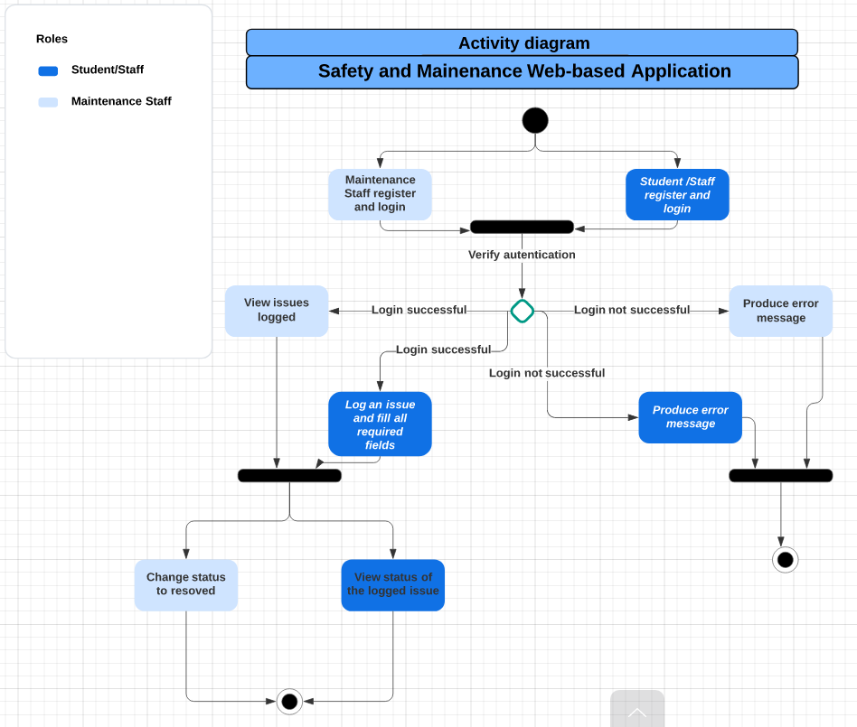

**Functionality**

* Four stakeholders will be interacting with the application: Student, Staff, System Administrator and Maintenance staff. (Check below screenshot)

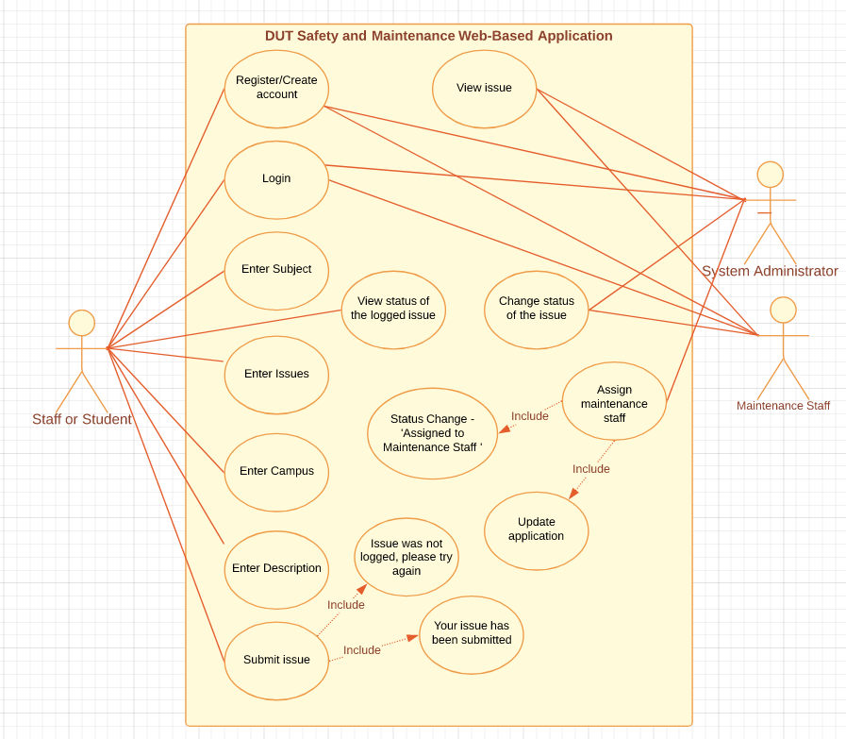

**Testing and Deployment**

Test Case #1 – Testing ‘Create account’ and ‘Login’

* Enter Full name.
* Enter Student/Staff number.
* Enter DUT email account.
* Enter password then create account.
* Expected to have an account created for that user, after creating the user must have access to the application by logging in

Test Case #2 – Testing the reporting functionality for Staff and Students

* Enter enter subject
* Enter issue
* Select campus
* Add description
* Submit the issue
* We are expecting to receive a pop up after submitting, saying ‘Your issue has been submitted’.

Test Case #3 – Testing the reporting functionality for System Admin

* Check if the administrator is able to view the issue.
* The administrator must be able to assign the issue to maintenance staff.
* We are expecting the request to be sent to the responsible staff.

Test Case #4 – Testing the reporting functionality for Maintenance staff

* Check if the maintenance staff member can view the issue.
* The staff must confirm they have received and viewed the issue.
* We are expecting the request to be view by the responsible staff and attend to the issue.

**Conclusion**

* The Functionality we are putting into place will very much assist the university maintenance department to keep track all the issue needed to be fixed around the school premises.
* This functionality will assist in keeping the school facilities well maintenance, and all facilities that requires maintenance will attended to as quick as possible.
* We are expecting all stakeholders to have access to the application. The involved stakeholders are Students & Staff, System Administrator and Maintenance Staff.
* Every stakeholder will be able to perform their functions.

Referencing

1. Lucid Charts

* [Activity diagram: Lucidchart](https://lucid.app/lucidchart/f23f1397-e8a8-4d60-8f33-579df1d53d33/edit?page=0_0&invitationId=inv_9ca25bbc-584f-449b-9210-b42a941aed26)
* [IT Elites: Lucidchart](https://lucid.app/lucidchart/137fe5b9-e1d4-43ff-b220-b1470159d9b8/edit?page=0_0)